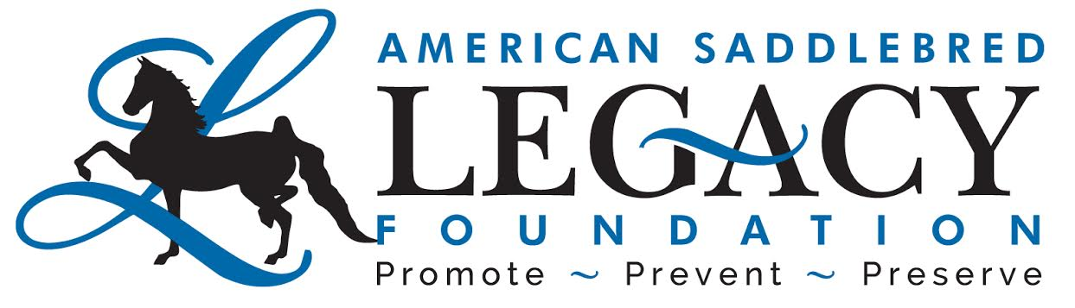
Congratulations! You have made the decision to explore adopting one of our horses or working with us through the process of buying a direct placement. We know that there is a lot to consider when deciding to add another equine to your family. Below we have laid out some expectations we would ask you to think about and be prepared to discuss with us, before we finalize the perfect placement!
At ASLF, we have tried many different ways to screen potential adopters and buyers. Overall, we have had the most success and believe that we are able to remove some of the traditional barriers of adoption such as lengthy applications and references, through relationship.
Together, we work with you and your family or trainer, to make sure we get the best fit possible for your current situation, needs and finances, and also for the horse that will become your future partner.
We understand that unexpected situations due to health, finances or life changes, may arise over time. Our very first interest and priority is be a support to you as an owner to provide stability for the horse should something unexpected arise. With that being said, we expect that you will do everything in your power to plan financially and otherwise should a life change occur, and be proactive in responsible actions to rehome or network your horse in transition.
Most of our horses have already come from a place of transition, so we are looking for some stability for them. We don’t always expect the next home to be a “forever” one, but we do expect you to be honest and up front from the beginning about your skill level and how much you plan to invest in time, money and gaining additional education for you or the horse, if needed.
Our goal is to see you both succeed. We want to support you both in your journey, but we expect that you will be prepared to commit to what that may take with your time and finances. We will be asking you questions about this.
We also expect that you will send us regular updates of you and your horse interacting. We work with each situation to find out what “regular” means for you. This is where the relationship comes in. We love getting the updates, but we also need them to help inspire others to take a chance on a adopting or a direct placement. It’s ok if things aren’t always perfect, that makes the experience even more relatable. And we want to help you stand in the gap when things aren’t what you expected.
Lastly, we expect that you introspectively spend time through this process answering questions honestly, and understanding your limitations. The excitement of a new friend is fun, but we are looking for long term relationships to be made between you, us and the horse you choose. Happy Horse Hunting!
The Board of The American Saddlebred Legacy Foundation

